**Aim - To create virtual computer (windows) through EC2 (Elastic Compute Cloud)**

**Theory –**

**cloud computing -** Cloud computing refers to the delivery of computing services—such as servers, storage, databases, networking, software, and analytics—over the internet (the "cloud"). Rather than owning and maintaining physical servers and other infrastructure, businesses and individuals can rent these resources from cloud service providers, allowing them to access and use them on-demand.

**key features –**

* **On-demand self-service**: Users can access and manage computing resources as needed without requiring human interaction with the service provider.
* **Broad network access**: Cloud services are available over the internet and can be accessed from various devices like laptops, smartphones, and tablets.
* **Scalability and elasticity**: Cloud services can scale up or down based on user needs, meaning that resources can be expanded or reduced as needed, making it more flexible and cost-effective.
* **Pay-as-you-go pricing**: Instead of investing in physical infrastructure, users pay only for the resources they actually use, which can reduce costs.

**Types of cloud computing models –**

* **Infrastructure as a Service (IaaS)**: Provides virtualized computing resources over the internet, such as virtual machines, storage, and networks (e.g., Amazon Web Services, Microsoft Azure).
* **Platform as a Service (PaaS)**: Offers a platform allowing customers to develop, run, and manage applications without dealing with the infrastructure (e.g., Google App Engine, Heroku).
* **Software as a Service (SaaS)**: Provides software applications over the internet, which users can access via a web browser, eliminating the need for installation or maintenance (e.g., Gmail, Microsoft Office 365)

**model - Infrastructure of regions , AZ and data center**

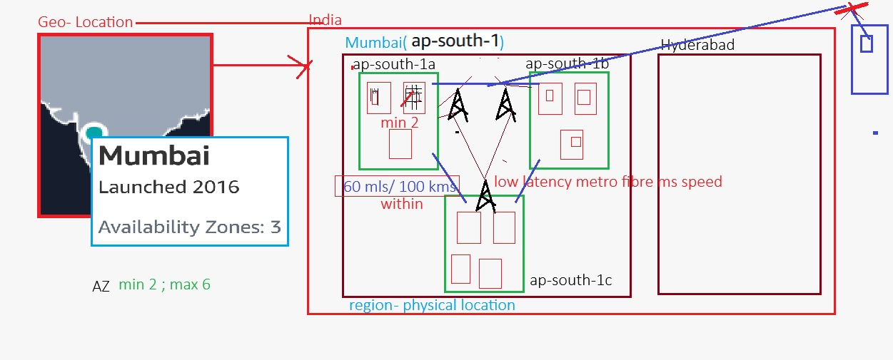

**flow -** geo-location < regions (eg. mumbai , singapore) < Availability zones (ap-south-1a) < data centers < racks (servers)

* **aws services -** regional and global (all regions)

**model - process of AWS services**

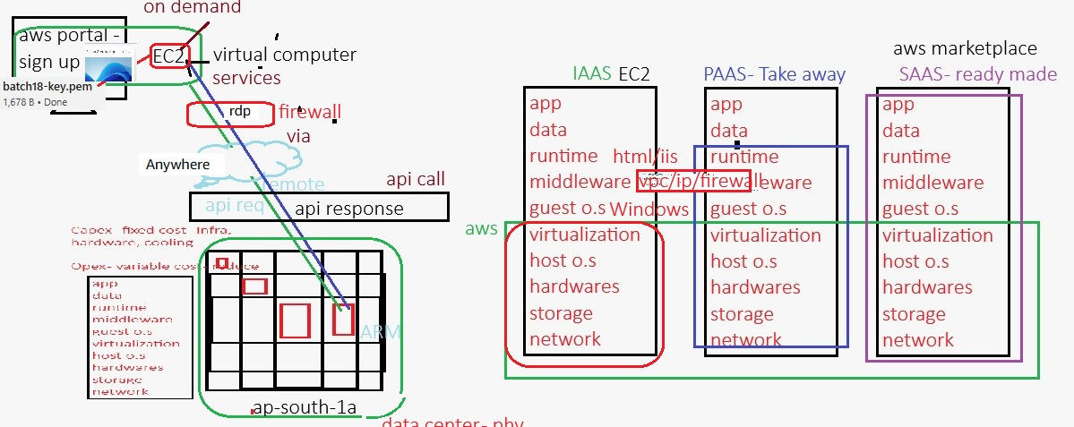

**RDP (Remote Desktop Protocol) -** it is a protocol developed by Microsoft that allows users to remotely connect to and control another computer or server over a network. It provides a graphical interface for users to access the desktop of a remote computer as if they were physically sitting in front of it. RDP is commonly used for remote administration, technical support, and accessing work computers from remote locations.

**VPC (Virtual Private Cloud) -** it is a private, isolated network within a public cloud environment, such as Amazon Web Services (AWS), Microsoft Azure, or Google Cloud. It allows users to define and control their own virtual networking environment, including aspects like IP address ranges, subnets, routing tables, and network gateways. Essentially, a VPC provides a secure and customizable network that simulates a traditional on-premises data center, but with the scalability and flexibility of the cloud.

**Amazon Machine Image (AMI) -** AMIis a pre-configured virtual machine image used to launch instances on Amazon EC2 (Elastic Compute Cloud). Essentially, AMIs are templates containing the operating system (OS), application server software, and other software configurations required to run applications on EC2 instances.

**private key format -**

* **.pem -** same source and destination (eg. windows to windows and ubuntu to centos )
* **.ppk -** Different source and destination (eg. GUI to CLI **i.e.** putty to ubuntu or centos)

**Model –** Architecture of EC2

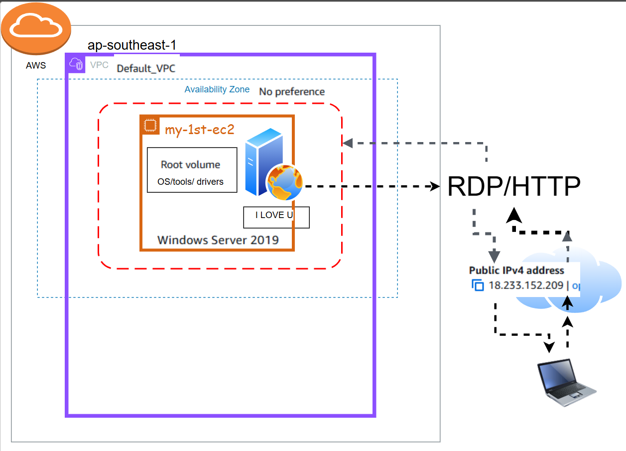

Practical –

Now create EC2 instance.

Step by step process –

* Login to AWS console

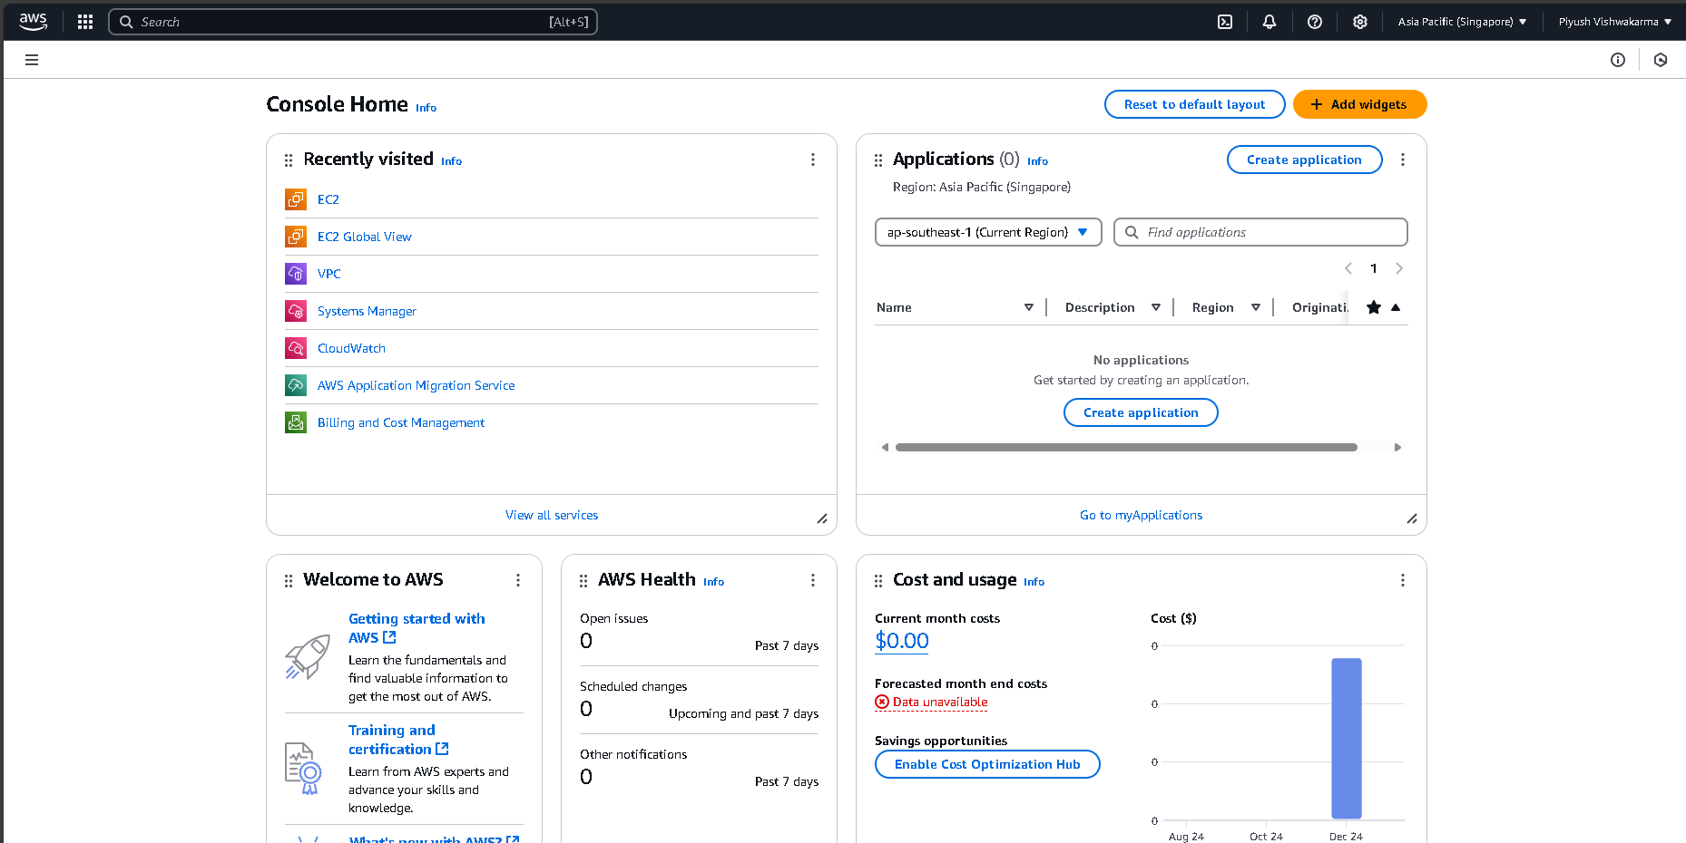

* Search EC2 in search bar

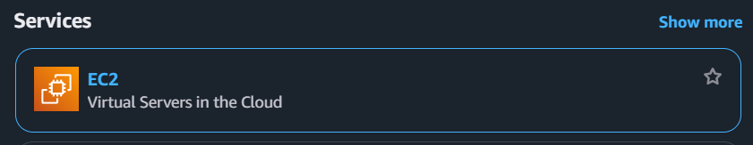

* Click on EC2 it will show this resources

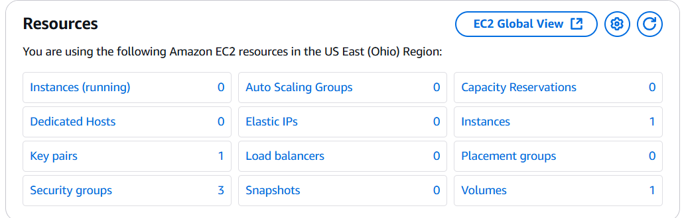

* Click on instances and launch instance.

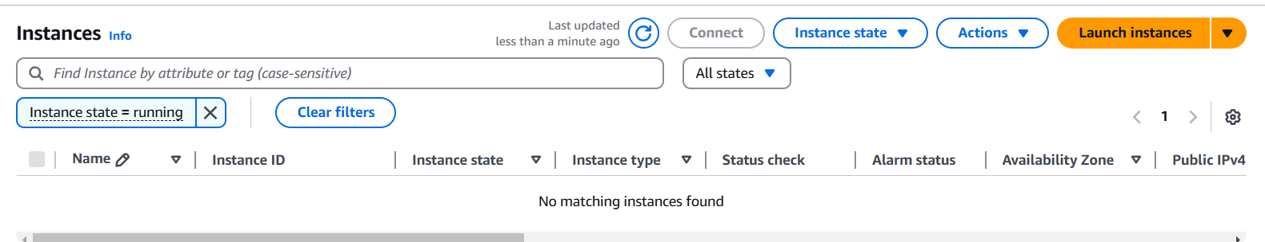

* After launching instance give system name whatever you want then choose here it is 2344 then choose OS system here it is windows

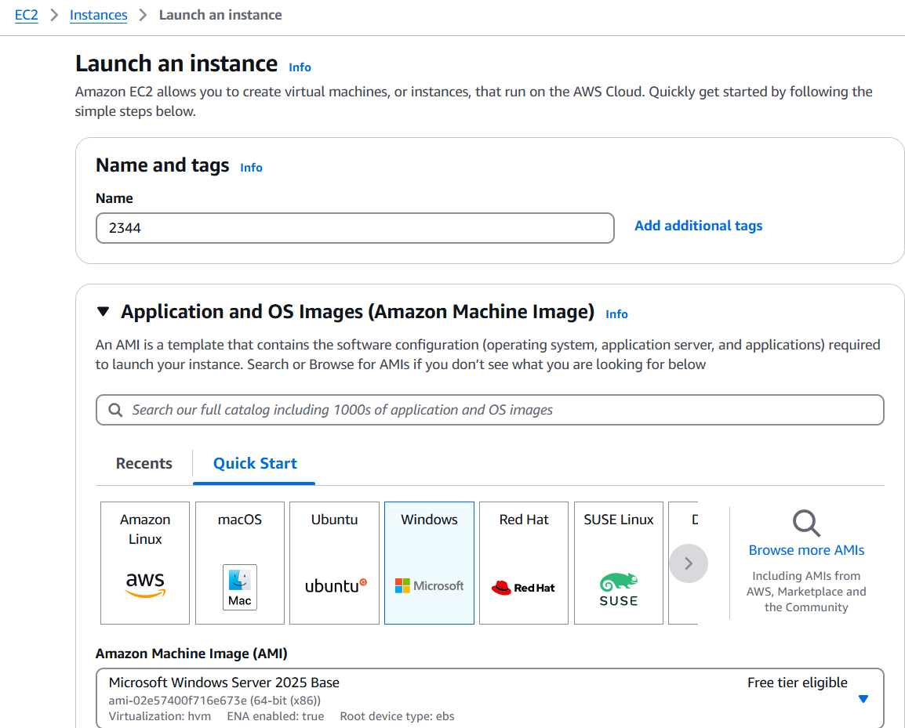

* **Instance Type**: Select a suitable type (e.g., t2.micro for free tier).

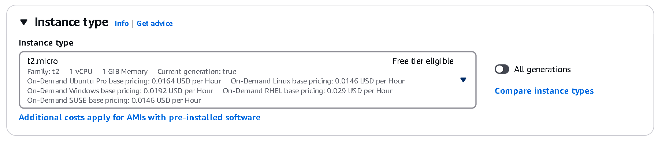

* Create key to get password to use for virtual computer when you create key for windows you have to get .pem file and it will automatically download in your computer.

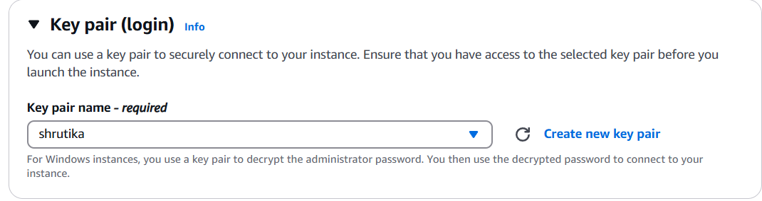

* Always use RDP traffic rules for windows and for linux use RDP And 3rd HTTP rule

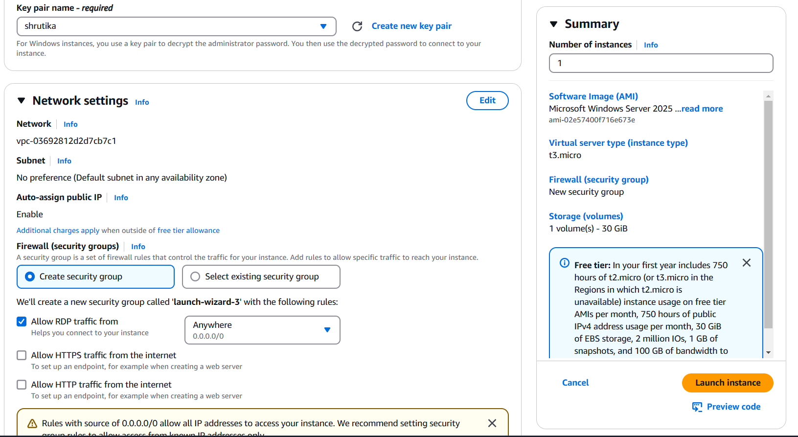

* Click on launch instance it shows you have successfully launch instance click on it shows instance that we created.

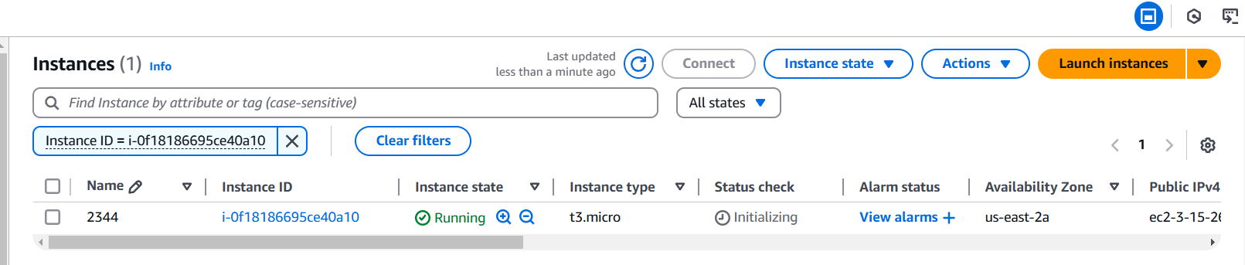

* Then click on that box of instance and click on option connect and choose RDP client which is use foe windows and for linux we use SSH client.
* Download remote desktop file.

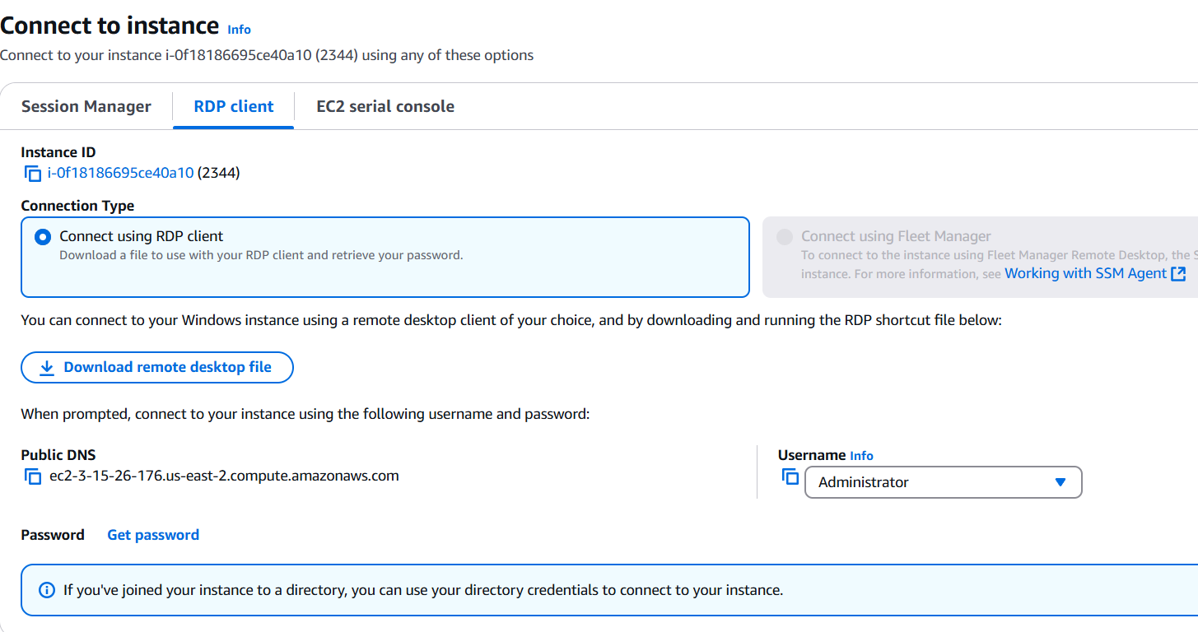

* click on get password upload .pem file from your computer and click on decrypt password after that it will show you password copy that.

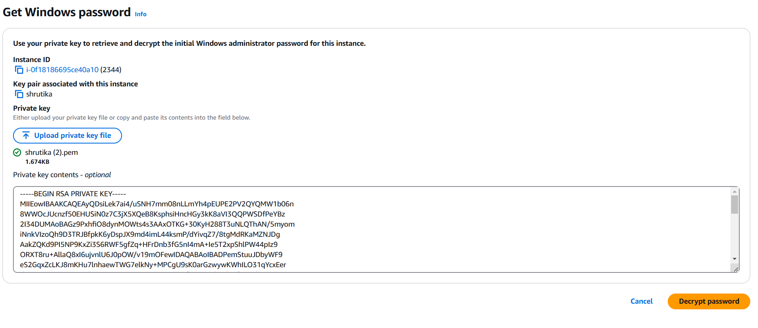

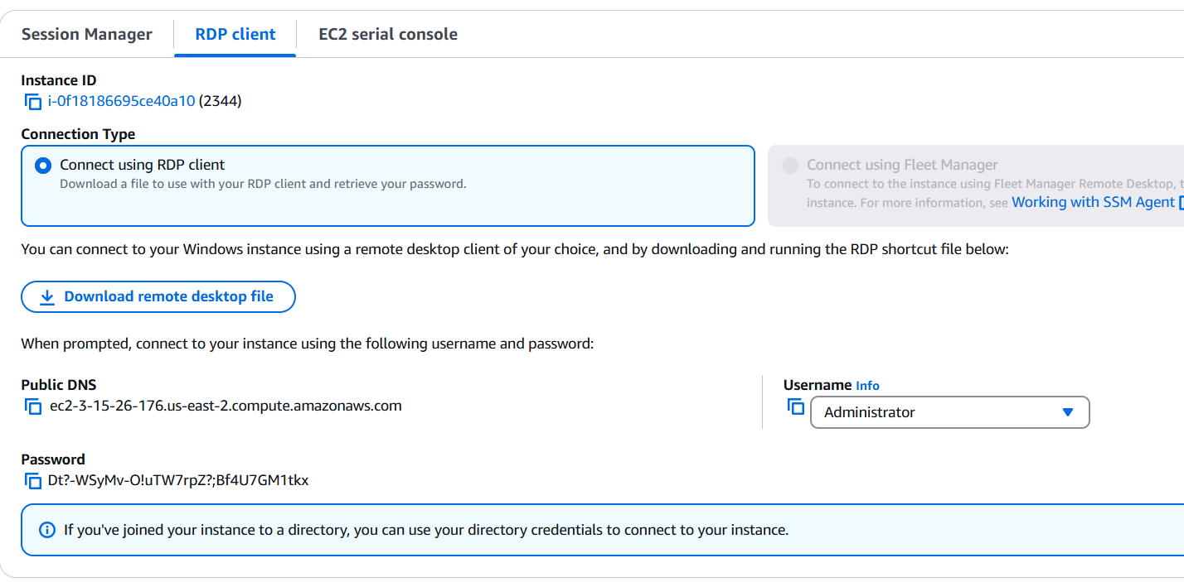

* click on remote desktop file which you download in this snapshot.
* Then click on it connect and put that copy password like above snapshot that you created through .pem file and decrypt it.

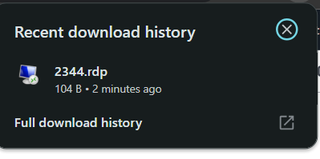

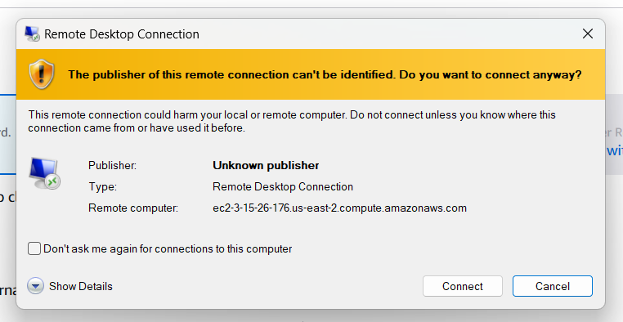

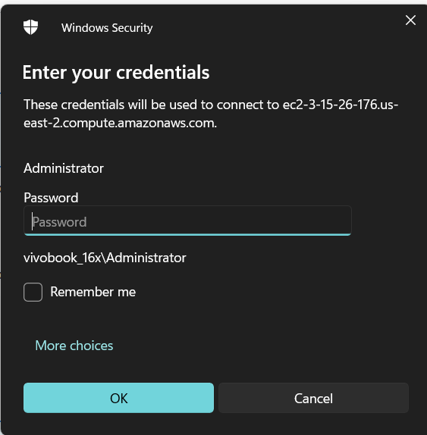

* After clicking on yes your virtual computer will be connected.

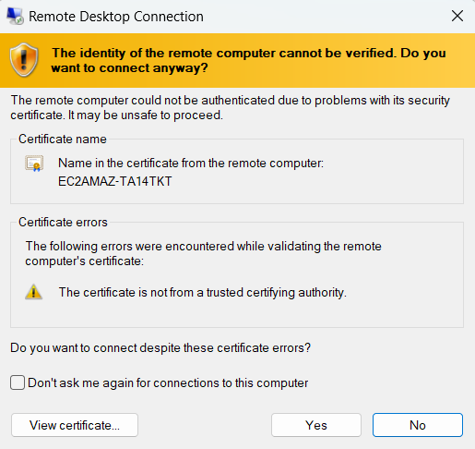

1. **Enable IIS Web Server:**
   * Open **Server Manager** > **Add roles and features**.

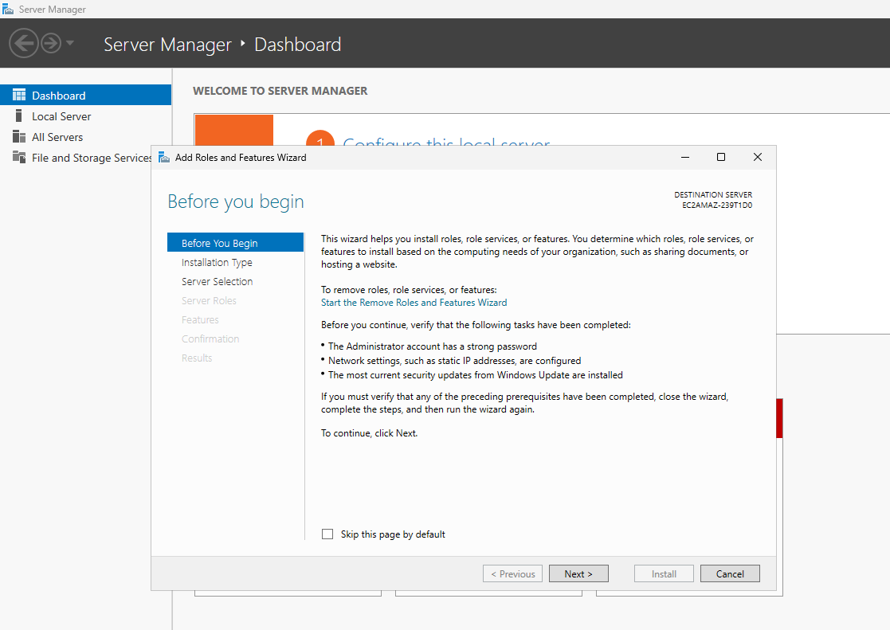

* + Select **Web Server (IIS)** and follow the wizard to install it.
    - **Why?:** IIS is required to serve web pages.

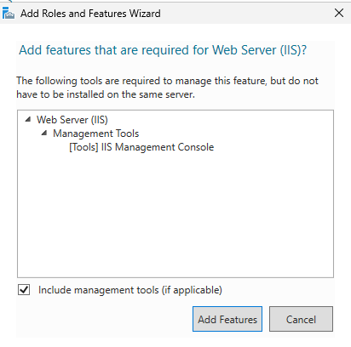

1. **Verify IIS Installation:**

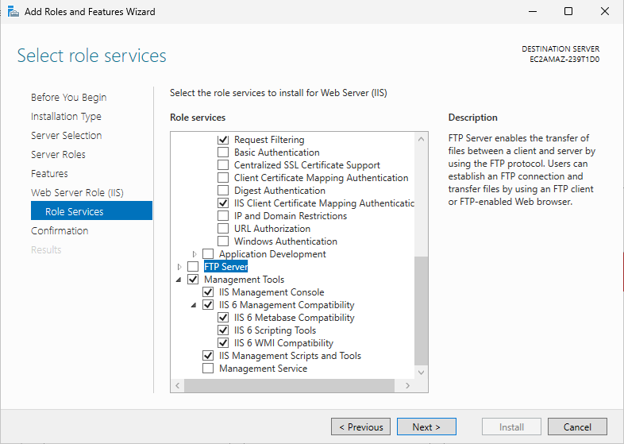

* + It Take Sometime to Install.

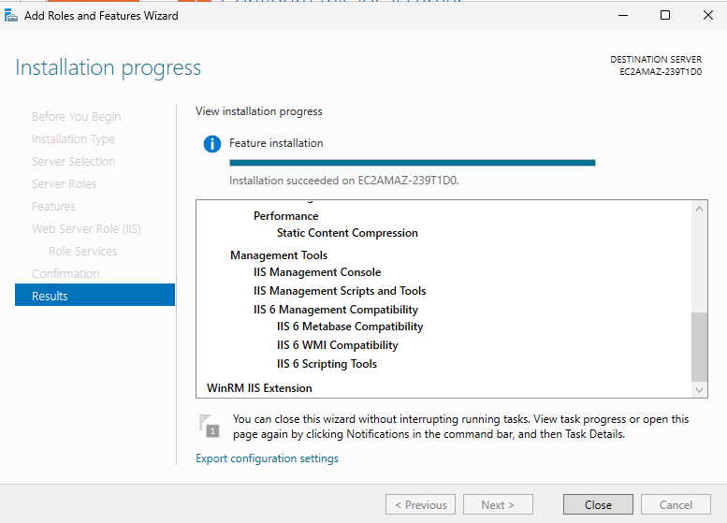

* + Open a browser and navigate to <http://18.141.195.193>.
  + The default IIS welcome page should load.
    - **Why?:** This confirms IIS is running.

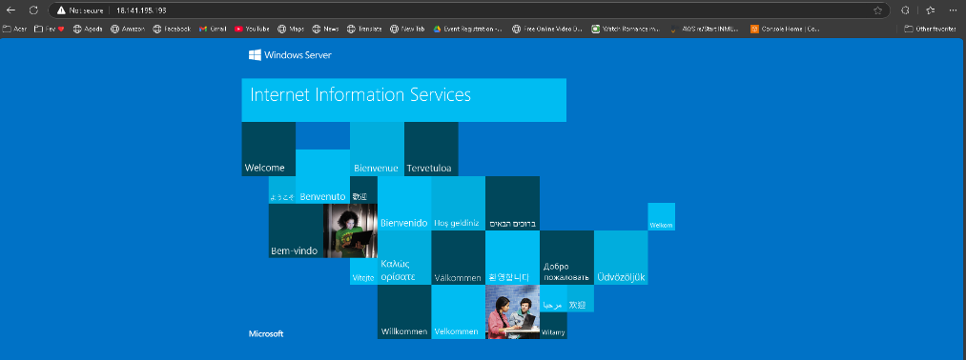

**Section 3: Deploying a Custom Project Website**

**Objective:**

To upload a custom HTML and CSS-based project to the Windows EC2 instance and serve it using IIS.

1. **Transfer the File:**
   * Copy Your Project Files into a Created Virtual Machine.
     + File will be paste in : C:\inetpub\wwwroot.

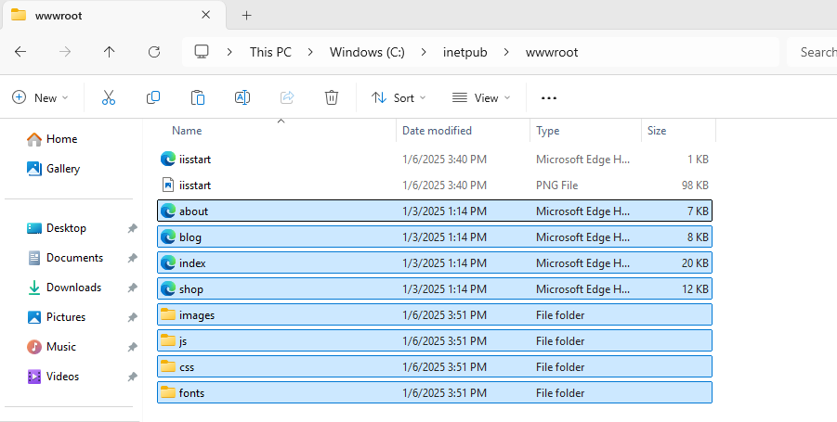

1. **Remove the Default IIS Web Page:**
   * Delete iisstart.htm from C:\inetpub\wwwroot\.

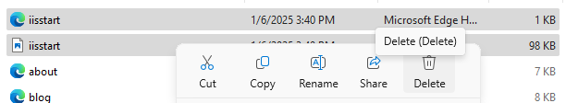

1. **Test the Custom Website:**
   * Open a browser and visit http://18.141.195.193.
   * Your custom website should now be displayed.
     + **Why?:** This confirms your project is deployed.

